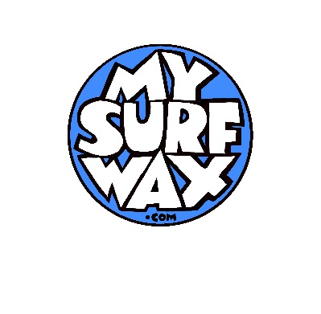
Manual order form for Custom made surf wax. Complete the form and send it to petermstrain@gmail.com. Any enquires direct them to Peter (61 416 164 732) or petermstrain@gmail.com.
Name of customer/Contact

Your address and Address for delivery of wax (if different)

Telephone

Email address

Product type
choose either
- Wax together with custom made wax boxes (four colours)
- Just wax (only wax, no box)
- Cold water (below 12 c or 53f)
- Cool water (below 13c-20c or 55f-68f)
- Warm water (19c-26c or 66f-79f)
- Tropical (above 25c or 77f)
- All water super sticky (all water conditions)
- Glow in the dark all water wax
Wax Scent: choose from
Coconut, vanilla, mango, berry, coffee, aniseed, banana, vanilla/coconut
Boxes: choose from
Kraft style (organic looking),
Matt or Gloss
Quantity
Just wax: Min quantity of 100
Boxed wax: quantities over 500
Artwork for the box
If you have the artwork, please up load it in the email or just send us what you have and we will work it out. Box template under the order tab.

Special requests:

Bank Details:

My Surf Wax Pty Ltd
NAB
BSB: 082 057
Account: 74 136 0847
SWIFT CODE NATAAU3303M

Bank Address: 255 George Street (Nab House) Sydney 2000 NSW

